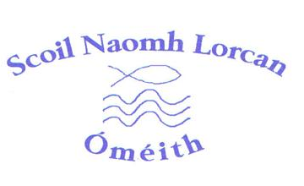

AFTERSCHOOL CLUB
Scoil Naomh Lorcan's afterschool club is a secure and friendly After School Club for Junior and Senior infants who have older siblings in school. It is a fantastic programme that continues to support your child's education in a fun environment

We would be grateful if you could indicate your consent for your child to take part in our afterschool club.

NAME OF CHILD
CLASS
CLASS TEACHER
CONTACT NUMBER
NAME OF PERSON COLLECTING CHILD

SIGNED:
PLEASE PRINT NAME:
RELATIONSHIP TO CHILD:
DATE:

